August-November 2024
CS616: Statistical Pattern Recognition
CS612: Statistical Pattern Recognition Laboratory
Programming Assignment 2 Report

Submitted by Group 03

Introduction

Classification is a fundamental problem in machine learning, where the goal is to determine the category or class of a new observation based on a training dataset with known class labels. This report explores classification using Gaussian Mixture Models (GMM), a probabilistic approach that models data as a combination of multiple Gaussian distributions, and K-means clustering, an unsupervised learning technique for partitioning data into clusters. By initializing GMM parameters with K-means, we aim to enhance model convergence and classification accuracy. The study applies these techniques to both synthetic data and real-world datasets, including speech data, scene images, and medical cell images, to analyze their effectiveness in capturing complex data patterns. Various configurations of GMM components are explored to assess the impact of model complexity on classification performance.

Dataset Description

Dataset 1: 2D Non-linearly Separable Synthetic Data with 2 Classes
This dataset consists of two-dimensional synthetic data points that belong to two distinct classes. The classes are non-linearly separable, meaning that a linear decision boundary cannot effectively distinguish between them. The dataset is designed to evaluate the classifier's ability to model complex decision boundaries. The same dataset was used in Assignment 1, allowing for a direct comparison of the performance improvements achieved using Gaussian Mixture Models (GMM) in the current assignment.

Dataset 2: Real-World Data

Dataset 2(a): Two-dimensional Speech Dataset (Vowel Data)
The vowel dataset consists of formant frequency data representing three different vowel classes. Each data point is a two-dimensional feature vector corresponding to the first two formant frequencies (F1 and F2) of the speech signal. The classes represent different vowels, making this a three-class classification problem. This dataset is also reused from Assignment 1, facilitating a comparison of the results with different classification approaches.

Dataset 2(b): Scene Image Dataset
The scene image dataset involves three classes of images, with each image represented using two different types of feature representations:
- 24-dimensional Color Histogram Features: Each image is divided into non-overlapping 32x32 patches. An 8-bin color histogram is computed for each RGB channel in a patch, resulting in a 24-dimensional feature vector for the patch. This representation captures the color distribution in different regions of the image.
- 32-dimensional Bag-of-Visual-Words (BoVW) Features: The 24-dimensional color histogram vectors from all training patches are clustered into 32 clusters using K-means. Each image is then represented by a 32-dimensional histogram of the frequency of occurrences of these clusters. This feature captures the distribution of visual patterns across the image.

Dataset 2(c): Cervical Cytology Cell Image Dataset
The cell image dataset consists of medical images used for cervical cytology analysis. Each image is divided into overlapping 7x7 patches, and two-dimensional feature vectors are computed from each patch based on the mean and standard deviation of pixel intensities. These features represent local texture information, which is useful for segmenting the image into three regions: nucleus, cell body, and background. The dataset is used to evaluate clustering-based segmentation techniques for medical image analysis.

Methodology

The methodology for this assignment involves implementing classification and clustering techniques using Gaussian Mixture Models (GMM) and K-means clustering across four different datasets. The goal is to evaluate the performance of a Bayes classifier built using GMM for various configurations, and to apply clustering for image segmentation in the case of medical images. The steps taken for each dataset are detailed below.
1. Data Preprocessing
Data preprocessing varies depending on the dataset:
- Dataset 1 (Synthetic Data): The synthetic dataset is split into 70% training and 30% testing subsets. No additional preprocessing is required.
- Dataset 2(a) (Speech Data): The vowel formant frequencies are normalized to zero mean and unit variance to ensure consistency in feature scaling. The data is then split into 70% training and 30% testing subsets.
- Dataset 2(b) (Scene Image Data): Two types of features are extracted:
  - Color Histogram Features: Each image is divided into 32x32 non-overlapping patches. An 8-bin histogram is computed for each RGB channel, and these histograms are concatenated to form a 24-dimensional feature vector for each patch.
  - Bag-of-Visual-Words (BoVW): The 24-dimensional color histogram features from all training patches are clustered into 32 clusters using K-means. The frequency of occurrences of these clusters in each image is used to form a 32-dimensional BoVW feature vector.
- Dataset 2(c) (Cell Image Data): Overlapping 7x7 patches are extracted from the images with a stride of 1 pixel. For each patch, the mean and standard deviation of pixel intensities are computed, resulting in a 2-dimensional feature vector.
2. Initialization Using K-Means Clustering
The GMM parameters are initialized using K-means clustering for each dataset:
- K-Means Initialization: The number of clusters (components) K is varied across different experiments (1, 2, 4, 8, 16, 32, 64). The centroids obtained from K-means clustering are used as the initial means for the Gaussian components in the GMM. This ensures a good starting point for the Expectation-Maximization (EM) algorithm used to optimize the GMM parameters.
- Shared Initialization Strategy: For datasets 2(b) and 2(c), the same initialization is used for different clustering methods to ensure consistency in comparisons.
3. Training Gaussian Mixture Models (GMM)
- Expectation-Maximization (EM) Algorithm: The EM algorithm is employed to iteratively update the parameters of the GMM to maximize the likelihood of the training data.
  - E-step: Compute the posterior probabilities (responsibilities) that each data point belongs to each Gaussian component based on current parameter estimates.
  - M-step: Update the parameters (means, covariances, and mixing coefficients) of each Gaussian component based on the computed responsibilities.
  - Convergence Criteria: The algorithm terminates when the log-likelihood difference between consecutive iterations is below a set threshold, indicating convergence. Regularization (adding a small value to the diagonal of covariance matrices) is used to avoid singularity issues.
- Experimentation with Different K: The GMMs are trained with different numbers of components (1, 2, 4, 8, 16, 32, 64) to study the effect of model complexity on classification performance.
4. Bayesian Classification Using GMM
- Bayes Classifier: After training the GMMs, a Bayes classifier is used to classify the test data. For each test data point, the posterior probability of belonging to each class is computed based on the trained GMM parameters. The class with the highest posterior probability is selected as the predicted class.
- Decision Boundaries and Constant Density Contours: For datasets 1 and 2(a), decision boundary plots are generated to visualize how the classifier partitions the feature space. Constant density contour plots show the regions of high probability density for each class.
5. Evaluation Metrics and Comparison
- Performance Metrics: The classification performance is evaluated using accuracy, precision, recall, and F1-score for each class. Mean precision, mean recall, and mean F1-score are also computed to assess overall performance.
- Confusion Matrix: For each dataset, a confusion matrix is generated for the best GMM configuration (based on the highest mean F1-score), showing the number of correct and incorrect classifications.
- Log-Likelihood vs. Iterations Plots: For each value of K, a plot of log-likelihood vs. the number of iterations is produced to analyze the convergence behavior of the EM algorithm.
- Comparison with Assignment 1: For datasets 1 and 2(a), results are compared with those from Assignment 1, where simpler linear classifiers were used. The comparison focuses on improvements in classification accuracy and boundary smoothness.
6. Clustering and Segmentation for Dataset 2(c) (Cell Image Data)
- K-Means Clustering: The extracted 2D feature vectors from the 7x7 patches are clustered into three groups using K-means. This clustering is used for segmenting the cell images into three regions: nucleus, cell body, and background.
- Modified K-Means (Mahalanobis Distance): An alternative clustering method using Mahalanobis distance is employed, which accounts for feature correlations and improves segmentation accuracy.
- Segmentation of Test Images: Each test image is segmented based on the clustering results. The cluster assignments are used to color-code the segmented regions, visually representing the different parts of the cell.
7. Feature Representation Impact Analysis (Dataset 2(b))
- Comparison Between Color Histograms and BoVW: For scene images, the two feature representations (24-dimensional color histograms and 32-dimensional BoVW vectors) are evaluated separately. The results are compared to understand which representation provides better classification performance.
- Feature Representation Impact on GMM Training: The different feature types may affect the convergence of the EM algorithm and the resulting GMM parameters. This is analyzed by comparing log-likelihood plots and classification metrics for both representations.
8. Handling Overfitting
- Regularization in GMM Training: A regularization term is added to the diagonal elements of the covariance matrices to prevent overfitting and numerical instability. This is especially important for large values of K.
- Choosing the Optimal KKK: Experiments with different values of K help identify the optimal number of components that balance model complexity and generalization. The best K is chosen based on the performance on the validation set or cross-validation.

Dataset-wise Implementation Details

Dataset 1 (2D Synthetic Data)

Implementation:
- Data Splitting: The dataset is split into 70% training and 30% testing data for each class.
- Initialization using K-Means: The parameters of the GMM (means of Gaussian components) are initialized using K-means clustering with K clusters for different values of K (1, 2, 4, 8, 16, 32, 64).
- GMM Training: The Expectation-Maximization (EM) algorithm is employed to train the GMM, iteratively updating the means, covariances, and mixing coefficients to maximize the likelihood of the data.
- Bayesian Classification: A Bayes classifier is implemented, where the posterior probabilities for each class are calculated using the GMM parameters. Each test point is assigned to the class with the highest posterior probability.
- Regularization: A small regularization term is added to the covariance matrices to avoid singularity issues.

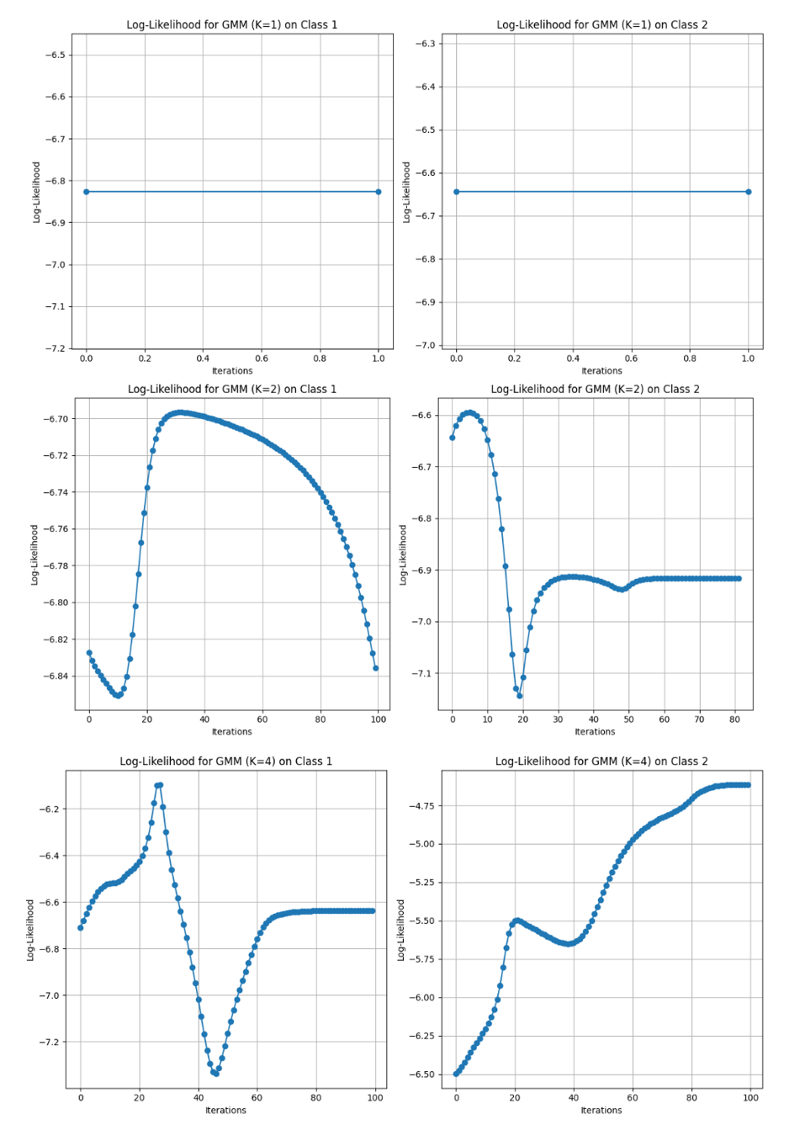
Log-Likelihood vs Iterations Plots
Figure 1 Log-Likelihood vs Iterations Plots for K = 1 to K = 4 for both the classes
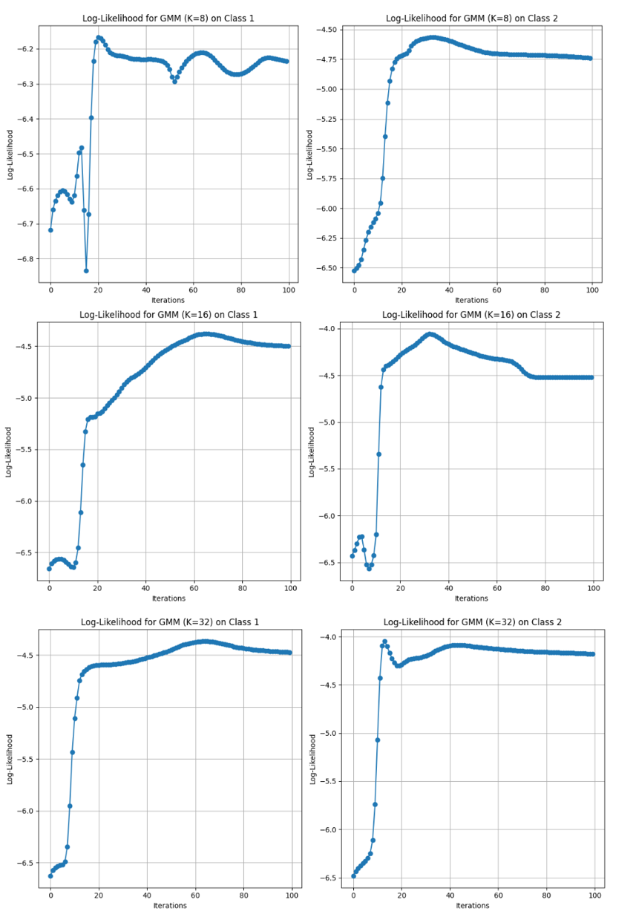
Figure 2 Log-Likelihood vs Iterations Plots for K = 8 to K = 32 for both the classes

Decision Regions Plots:

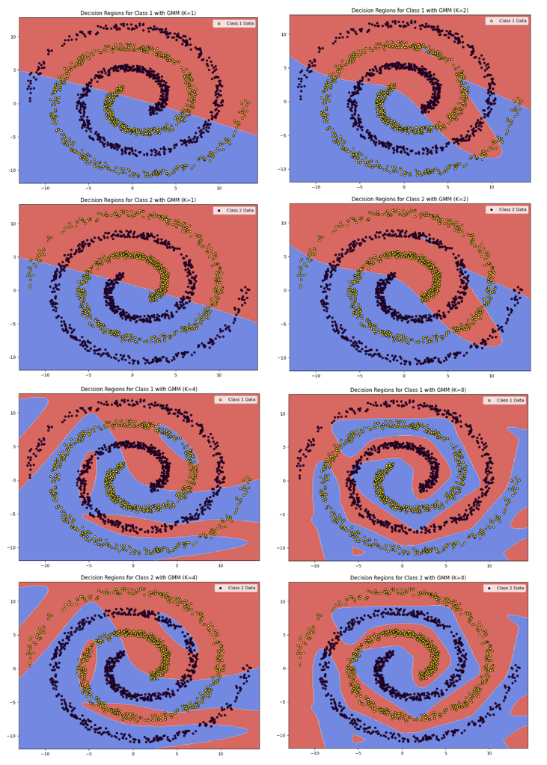
Figure 3 Decision Regions Plots for K = 1 to K = 8 for both classes
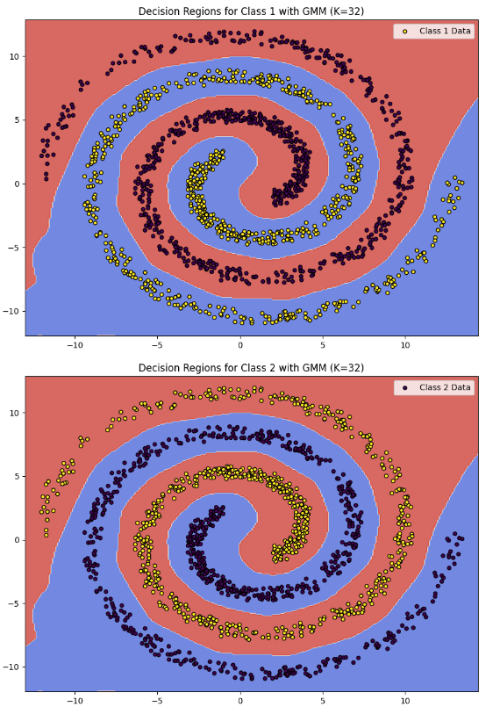
Figure 4 Decision Regions Plots for K = 32 for both classes

Constant Density Contour Plot:
- Decision region plots and constant density contour plots for the best GMM model.
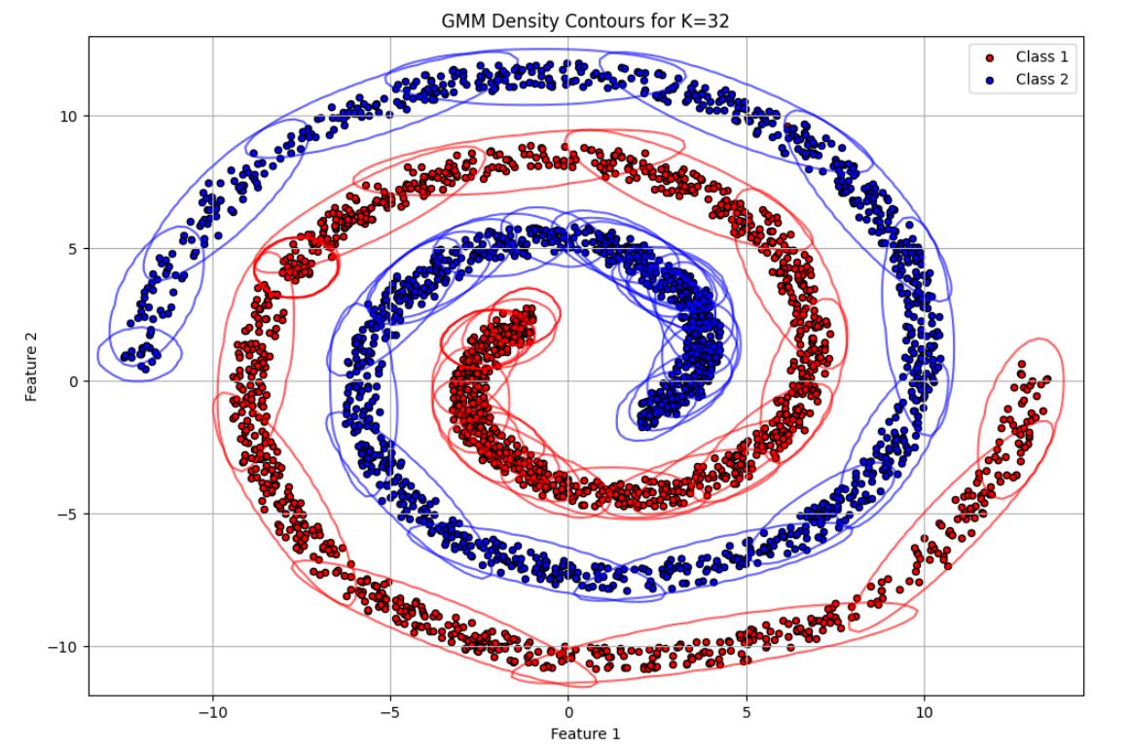
Figure 5 Constant Density Contour Plot for K = 32
K (Clusters) | Accuracy | Precision | Recall | F1-Score
1 | 0.6215 | 0.6216 | 0.6215 | 0.6214
2 | 0.6304 | 0.6309 | 0.6304 | 0.6300
4 | 0.8387 | 0.8396 | 0.8387 | 0.8386
8 | 0.9952 | 0.9953 | 0.9952 | 0.9952
16 | 1.0000 | 1.0000 | 1.0000 | 1.0000
32 | 1.0000 | 1.0000 | 1.0000 | 1.0000

Performance metrics
Table 1 Performance metrics for different numbers of GMM clusters
Actual \ Predicted | Class 0 | Class 1
Class 0 | 735 | 0
Class 1 | 0 | 734
Table 2 Confusion matrix for GMM model with K = 16 or K = 32

Observations:
- Log-Likelihood vs. Iterations: From Figure 1, The log-likelihood values increase monotonically with iterations for different values of K, indicating proper convergence of the EM algorithm. Higher K values tend to show more gradual convergence.
- Classification Metrics: As shown in Table 1, Performance metrics including accuracy, precision, recall, and F1-score for each class are computed. The best results are obtained for moderate values of K (e.g., 8 or 16), balancing model complexity and generalization ability.
- Confusion Matrix: The confusion matrix as shown in Table 2 for the best GMM model indicates the classifier’s ability to correctly classify test samples.
- Decision Boundary and Contour Plots: Plots shown in Figures 3, 4 and 5 show how the GMM classifier divides the feature space. Lower K values produce smoother boundaries, while higher K values result in more intricate decision regions.

Inference:
- Impact of K: Small K values underfit the data, resulting in poor classification accuracy. Increasing K improves the model’s ability to capture the data's underlying structure, but very high K values can lead to overfitting.
- Comparison to Assignment 1: Compared to the previous assignment, where linear classifiers were used, the GMM-based approach significantly improves classification accuracy due to its ability to model complex decision boundaries in non-linearly separable data.

4.2. Dataset 2(a) (Speech Data)

Implementation:
- Data Splitting: The vowel data is divided into 70% training and 30% testing subsets for each class.
- Preprocessing: Formant frequencies (F1 and F2) are normalized to have zero mean and unit variance.
- K-Means Initialization: The initial means for the GMM are set using K-means clustering, experimenting with different numbers of components (1, 2, 4, 8, 16, 32, 64).
- GMM Training: The EM algorithm refines the GMM parameters (means, covariances, mixing coefficients) to fit the training data.
- Classification: A Bayes classifier is used to predict the class of each test sample based on the learned GMMs.

Observations:
- Log-Likelihood Convergence: The log-likelihood increases with each iteration, stabilizing after a few iterations for lower values of K. Higher K values require more iterations to converge.
- Performance Metrics: Accuracy, precision, recall, and F1-score are calculated for each class. A value of K around 8 or 16 typically yields the best performance, indicating sufficient complexity to model the speech data distribution.
- Confusion Matrix: The confusion matrix for the optimal GMM model demonstrates the classifier’s effectiveness in distinguishing between the vowel classes.
- Contour and Decision Boundary Plots: For moderate K values, the decision boundaries accurately separate the classes, demonstrating the classifier's capability to handle non-linear separability.

Inference:
- Model Complexity: With lower K, the classifier has a limited ability to model the data distribution, resulting in lower classification accuracy. Increasing K improves the model’s flexibility but also increases the risk of overfitting.
- Comparison to Assignment 1: The GMM classifier outperforms the previous linear methods by better modeling the non-linear separability of vowel data.

Plots:
  - Decision boundaries and contour plots for the best model.

4.3. Dataset 2(b) (Scene Image Data)

Implementation:

The implementation for Dataset 2(b) involves using K-means clustering to initialize the parameters for a Gaussian Mixture Model (GMM), followed by training the GMM using the Expectation-Maximization (EM) algorithm for classification. Two different feature representations are used for the images: 24-dimensional color histograms and 32-dimensional Bag-of-Visual-Words (BoVW).
1. Feature Extraction
- Color Histogram Features:
  - Each image is divided into non-overlapping 32x32 patches.
  - An 8-bin histogram is calculated for each RGB channel in a patch, resulting in three separate 8-dimensional vectors.
  - These histograms are concatenated to form a 24-dimensional feature vector for each patch.
- Bag-of-Visual-Words (BoVW) Features:
  - The 24-dimensional color histogram features from all training images are used to form a visual vocabulary by clustering them into 32 clusters using K-means.
  - Each image is then represented by a 32-dimensional histogram, which counts the number of feature vectors assigned to each cluster (BoVW representation).
2. K-means Clustering Algorithm
The K-means clustering algorithm is used to initialize the parameters of the GMM. The steps involved are as follows:
- Cluster Assignment (Similarity Calculation):
- The cluster assignment step is based on the Euclidean distance between each data point $x_{n}$ and the current centroid $μ_{k}$ of the $k$-th cluster. The distance is computed as:
$$\text{distance}\left(x_{n},μ_{k}\right)=∥x_{n}-μ_{k}∥^{2}={\left(x_{n}-μ_{k}\right)}^{T}\left(x_{n}-μ_{k}\right)$$
- Where:
  - $x_{n}$ is the $n$-th data point.
  - $μ_{k}$ is the centroid of the $k$-th cluster.
- Each data point is assigned to the cluster with the minimum distance.
  - Each data point is assigned to the cluster with the smallest distance.
- Updating Centroids:
- After assigning each data point to a cluster, the new centroid $μ_{k}$ for the $k$-th cluster is updated as the mean of all points assigned to that cluster:
μk=1Nkxn∈Ck​xn
- Where:
  - $N_{k}$ is the number of points assigned to the $k$-th cluster.
  - $C_{k}$ is the set of all points assigned to the $k$-th cluster.

- Covariance Matrix Update:
The covariance matrix $Σ_{k}$ for each cluster is calculated as:
Σk=1Nkxn∈Ck​xn-μkxn-μkT

- Convergence Criterion:
  - The algorithm iterates through the cluster assignment and centroid update steps until the centroids' positions change by less than a specified threshold, indicating convergence.
Once the clustering is completed for each class using K-means, the final cluster parameters (centroids and covariances) are used to initialize the GMM for each class.
3. GMM (Gaussian Mixture Model) - EM Algorithm
The Expectation-Maximization (EM) algorithm is used to train the GMM, iterating between the E-step (Expectation step) and M-step (Maximization step).
- Gaussian Probability Density Function (PDF):
- The formula used to compute the likelihood of a sample $x_{n}$ under a Gaussian distribution $N\left(x_{n}∣μ_{k},Σ_{k}\right)$ is given by:
$$p\left(x_{n}∣μ_{k},Σ_{k}\right)=\frac{1}{{\left(2π\right)}^{d/2}∣Σ_{k}∣^{1/2}}exp\left(-\frac{1}{2}{\left(x_{n}-μ_{k}\right)}^{T}Σ_{k}^{-1}\left(x_{n}-μ_{k}\right)\right)$$
- Where:
  - $d$ is the dimensionality of the data.
  - $x_{n}$ is the $n$-th data point.
  - $μ_{k}$ is the mean of the $k$-th Gaussian component.
  - $Σ_{k}$ is the covariance matrix of the $k$-th Gaussian component.
  - $∣Σ_{k}∣$ is the determinant of the covariance matrix.
  - $Σ_{k}^{-1}$ is the inverse of the covariance matrix.

- Responsibilities (Expectation Step):
The responsibility $γ_{nk}$ (probability that the $n$-th sample $x_{n}$ belongs to the $k$-th Gaussian component) is computed in the Expectation step (E-step) as:
$$γ_{nk}=\frac{π_{k} N\left(x_{n}∣μ_{k},Σ_{k}\right)}{\sum_{j=1}^{K}{π_{j}} N\left(x_{n}∣μ_{j},Σ_{j}\right)}$$
  - $π_{k}$ is the mixing coefficient (weight) for the $k$-th Gaussian component.
  - $N\left(x_{n}∣μ_{k},Σ_{k}\right)$ is the Gaussian PDF as defined above.
  - The denominator is the sum of Gaussian PDFs over all $K$ components.

- Updating Means (Maximization Step):
The updated mean $μ_{k}$ for each Gaussian component is calculated using the responsibilities in the Maximization step (M-step):
$$μ_{k}=\frac{\sum_{n=1}^{N}{γ_{nk}}x_{n}}{\sum_{n=1}^{N}{γ_{nk}}}$$
- Where:
  - $γ_{nk}$ is the responsibility that sample $x_{n}$ belongs to the $k$-th Gaussian component.
  - $N$ is the total number of data points.

- Updating Covariances (Maximization Step):
- The updated covariance matrix $Σ_{k}$ for each Gaussian component is:
$$Σ_{k}=\frac{\sum_{n=1}^{N}{γ_{nk}}\left(x_{n}-μ_{k}\right){\left(x_{n}-μ_{k}\right)}^{T}}{\sum_{n=1}^{N}{γ_{nk}}}$$
- Where:
  - $γ_{nk}$ is the responsibility of the $n$-th sample for the $k$-th Gaussian component.
  - $x_{n}-μ_{k}$ is the difference between the sample and the updated mean for the $k$-th component.

- Updating Weights (Mixing Coefficients):
- The updated mixing coefficient (weight) $π_{k}$ for the $k$-th Gaussian component is:
$$π_{k}=\frac{1}{N}\sum_{n=1}^{N}{γ_{nk}}$$
- Where:
  - $N$ is the total number of data points.
  - $γ_{nk}$ is the responsibility of the $n$-th sample for the $k$-th Gaussian component.

- Log-Likelihood Calculation:
- The log-likelihood $L$ is computed at each iteration to track the convergence of the EM algorithm:
$$L=\sum_{n=1}^{N}{log}\left(\sum_{k=1}^{K}{π_{k}} N\left(x_{n}∣μ_{k},Σ_{k}\right)\right)$$
- Where:
  - $N$ is the number of data points.
  - $K$ is the number of Gaussian components.

Once the GMM is build for each of class, then we will compute the likelihood for new test sample feature vector x and the final label for new test sample is, which has maximum likelihood.
  - Class Label for x = argmax $p(\frac{x}{θi})$
  - The EM algorithm continues iterating until the change in log-likelihood falls below a specified threshold.
- Classification Using GMM
After the GMMs are trained for each class, a Bayes classifier is used to classify new test samples:
- For a given test feature vector x, compute the likelihood for each class.
- The class label is assigned based on the maximum posterior probability:
Class Label for x = argmax $p(\frac{x}{θi})$
where θ_{i} ​ represents the GMM parameters

Log-Likelihood vs Iterations Plots
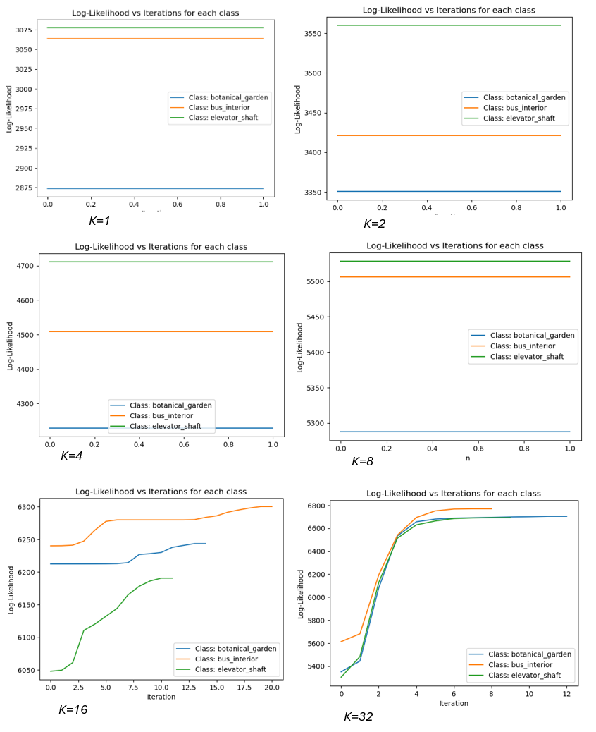

Observations:
  - Separate log-likelihood plots for color histogram and BoVW features.
  - Report performance metrics and confusion matrices for both representations.

Inference:
  - Compare results for color histograms and BoVW features.
  - Analyze how feature representation influences classification outcomes.

4.4. Dataset 2(c) (Cell Image Data)

Implementation:
  - Extract 2D feature vectors from overlapping patches of training images.
  - Perform K-means and modified K-means (Mahalanobis distance) clustering.
  - Segment test images by assigning each patch to one of the clusters.

Observations:
  - Display segmentation results for both clustering methods.
  - Report on the number of clusters and the performance on different cell regions.

Inference:
  - Compare the effectiveness of K-means and modified K-means in segmenting medical images.

Plots:
  - Display segmented regions for test images, highlighting different cell structures.

5. Comparative Analysis
- Discuss how varying the number of mixtures K impacts performance across all datasets.
- Summarize key differences between GMM classification results and Assignment 1 (for Datasets 1 and 2a).
- Discuss the choice of features for Dataset 2(b) and the clustering approach for Dataset 2(c).

6. Conclusions
- Summarize key findings from the experiments.
- Highlight the importance of selecting an appropriate number of GMM components.
- Discuss the impact of feature representation on classification and clustering performance.

7. References
- Bishop, C. M. (2006). Pattern Recognition and Machine Learning. Springer.
- Duda, R. O., Hart, P. E., & Stork, D. G. (2000). Pattern Classification. Wiley.
- Murphy, K. P. (2012). Machine Learning: A Probabilistic Perspective. MIT Press.
- Mitchell, T. M. (1997). Machine Learning. McGraw-Hill.

